1.

Me -> forgot some formatting

Francesco -> all row in output

Isabela -> correct formatting

2.

Me -> seems ok

Francesco -> missing 1 row

Isabela -> missing 2 row. Change '9999.99' to ''999999.99' to display correct number.

3.



Francesco

Isabela



My interpretation of the question ->

(Employees with 0/Null commission || Employees in sales)

AND

(Monthly Salary + Monthly Salary * Commission + 1000) > 15000

4. same results

5. Employees outside US. Executive dept 90 is at location id 1700 -> located in US

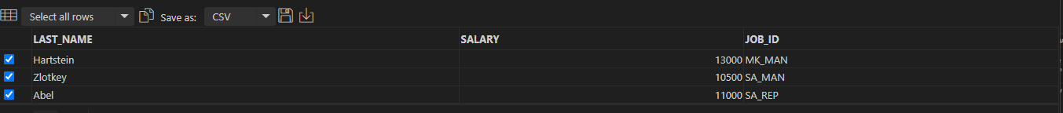

Hunold -> 60 Location ID -> & AC_MGR -> 110. Both of them are in US.

6.

Me -> used < instead of >. Wrong output

7.   
  
  
  
Francesco -> Missing AC_MGR(manager) in your filter so Max salary is record as 12000 instead of 11000. Results in extra record.  
  
job_id NOT LIKE '%PRES%' AND

job_id NOT LIKE '%MAN%' AND

job_id NOT LIKE '%VP%'  
  
8.

Me -> Incorrect. Included department with 0 employee.